PETER JAMES C. FERRERAS  #09B Sandoy Street, Brgy. Poblacion, Alaminos City. Pangasinan  Mobile Number: 09090619498  Email: ferreraspeter22@gmail.com  OBJECTIVES:  To apply my ICT skills and gain hands-on experience through work immersion while developing professionalism, communication skills, and technical knowledge.  PERSONAL DATA:  Date of Birth : July 20, 2006  Age : 19 years old  Place of Birth : Alaminos City, Pangasinan  Civil Status : Single  Citizenship : Filipino  Religion : Jehovah’s Witnesses  Height : 175 cm  Weight : 104 kg  Father’s Name : Richard O. Ferreras  Occupation : Barber  Mother’s Name : Frannie C. Ferreras  Occupation : OFW  SKILLS SUMMARY:  - Information Communication Technology  - Able to speak and understand English and Filipino Language  - Has a good communication skill  - Friendly  - Dependable | 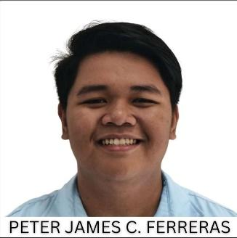  EXPERIENCE/ACHIEVEMENT:  Champion – Stand up And Deliver  STI Alaminos, 2026  2nd Runner-Up – Impromptu Speech  STI Alaminos, 2025  Radio Broadcaster (Anchor)  The Great Plebeian Torch  Got third place at DSPC 2023  (This achievement was repeated in DSPC 2024.)  With Honors  Grade 11 ICT  Average at 91  With Honors  Grade 12 ICT  Average at 93  Web Developing  Grade 11-12 ICT  Has experience in making a webpage  Graphic Designing  Has experience in making Graphic Design  Has experience in Making Floor Plan in AutoCad  Work Immersion  L&J Graphtechs Sublimation Graphic Designing  School Campaign Marketing  Strand Representative TVL-ICT  I hereby certify that the above information is true and correct to the best my knowledge and beliefs.
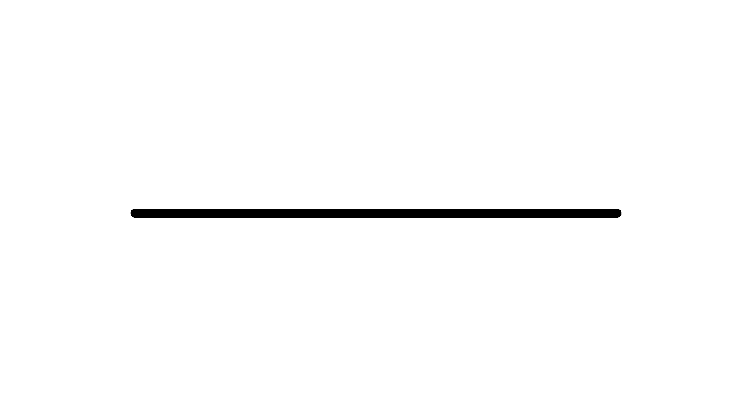

EDUCATION:
Tertiary: 2-Year Information Technology
STI Alaminos
08 Marcos Ave., Alaminos City, Pangasinan
2024 – present

Senior High: The Great Plebeian College
Gen. Montemayor St, Alaminos City, Pangasinan
2022 - 2024

Junior High: The Great Plebeian College
Gen. Montemayor St, Alaminos City, Pangasinan
2017 - 2022

Elementary: Alaminos Central Elementary School
San Jose Dr, Poblacion, Alaminos City, Pangasinan
2011 - 2017

PETER JAMES C. FERRERAS Applicant Signature

